Chapter 6 Scalars and vectors

Chapter test answers Total marks 50

Section A

Question 1

B (1 mark)

Question 2

A (1 mark)

Question 3

D (1 mark)

Question 4

D (1 mark)

Question 5

A (1 mark)

Question 6

B (1 mark)

Question 7

A (1 mark)

Question 8

D (1 mark)

Question 9

B (1 mark)

Question 10

C (1 mark)

Section B

Question 11

Use a sign convention to calculate the resultant vector for the following vector sums:

a 35.0 N south + 22.0 N north + 25.5 N south + 15.5 N north.



*R* = (–35.0) + (22.0) + (–25.5) + (15.5) (1 mark)

= –23.0 N

= 23.0 N south (1 mark)

b 17.5 N north – 10.0 N south.



*R* = (+17.5) – (–10.0) (1 mark)

= +27.5

= 27.5 N north (1 mark)

Question 12

A car goes 1.00 km east, 2.00 km south, 3.00 km west and 4.00 km north.

a i Distance north:



*R* = (–2.0) + (+4.0) (1 mark)

= +2.0

= 2.0 km north (1 mark)

ii Distance east or west:



*R* = (+1.0) + (–3.0) (1 mark)

= –2.0 km

= 2.0 km west (1 mark)

b Resultant displacement:

 = (+2.0)2 + (–2.0)2 (1 mark)

 = 

= 2.8 km northwest (1 mark)

Question 13

a Total distance travelled by the car:

*s* = (20.0) + (15.0)

= 35.0 m (1 mark)

b Final displacement from the rubbish bin:

 = (20.0)2 + (15.0)2

 = 

= 25.0 m (2 marks)

tan = 0.750

 = 36.7

 = 25.0 m N36.7E (1 mark)

(1 mark)

20.0 m

15.0 m

Question 14

a scale (1 mark)

1 m s–1 sections (1 mark)

stationary section (1 mark)

return to road section (1 mark)

0 10 20 30 40 50 60 70 80 Time (s)

80

70

60

50

40

30

20

10

Displacement (m)

b Total distance covered:

*s* = (1.50 ×15.0) + (0 × 10.0) + (2.50 × 5.0) + (1.50 × 25.0) + (1.50 × 25.0) (1 mark)

= (22.5) + (0) + (12.5) + (37.5) + (37.5)

*=* 110 m (1 mark)

c Final displacement:

*s* = (1.50 × 15.0) + (0 × 10.0) + (2.50 × 5.0) + (1.50 × 25.0) + (1.50 ×–25.0) (1 mark)

= (22.5) + (0) + (12.50) + (37.5) + (–37.5)

= 35.0 m west (1 mark)

Question 15

a scale (1 mark)

sections for the first repetition (1 mark)

sections for the second repetition (1 mark)

0 20 40 60 80 100 120 140 160 time (s)

400

350

300

250

200

150

100

50

0

Distance (m)

b scale (1 mark)

1 m s–1 sections (1 mark)

stationary section (1 mark)

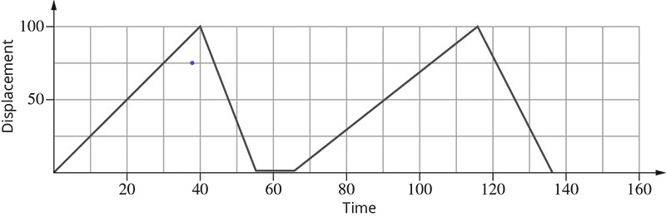

Question 16

a The three forces added correctly (1 mark)

Resultant force drawn correctly (1 mark)

Scale used correctly (1 mark)

*R* is approximately 2400 N (1 mark)

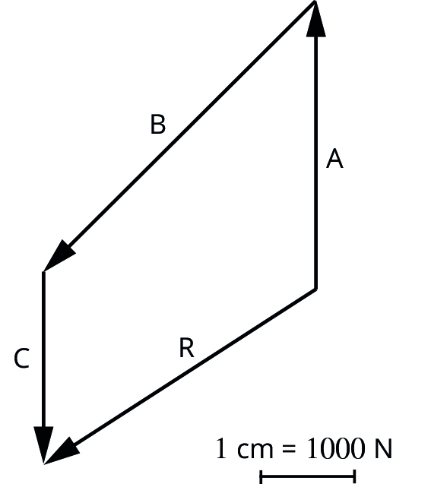

b

*F*2 = (5000)2 + (4500)2

*=* N

*=* 6276 N (1 mark)

tan =  = 0.900

 = N 42E (1 mark)

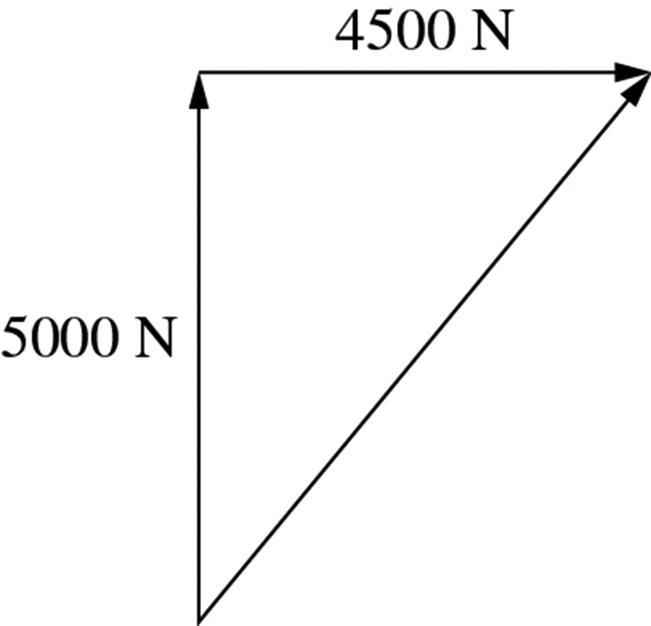

Question 17

*F*friction  (1 mark)

*F*g (1 mark)

*F*g down slope (1 mark)

*F*g into slope (1 mark)

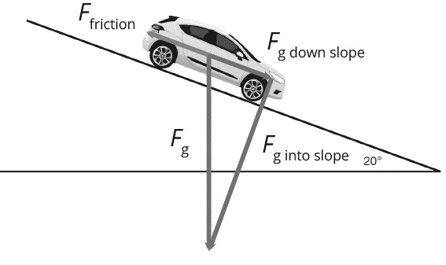

Question 18

Neither has a greater displacement. (1 mark)

Both the football and the player start at the same position as each other and finish at the same position as each other. (1 mark)

Therefore both are the same displacement from their original positions. (1 mark)